**User Manual**

1. Make sure you have the required libraries installed. Here are some links to them if you do not have them installed.

Python 3.5+

<https://www.python.org/downloads/>

Scipy

<https://www.scipy.org/install.html>

Jupyter Notebook

<http://jupyter.readthedocs.io/en/latest/install.html>

Alternatively you can install Anaconda, but we don’t endorse this option.

1. Now make sure you have both of our files in the same directory. The two files should be called “Data Mining Project.ipynb”, and then whatever csv you’re going to use. Note that the csv’s should be in the format of x-cord, y-cord \newline.
2. Now just open the file in jupyter notebook and run it. Assuming you’re using Ubuntu here is roughly what it will look like:

cd ~/Path/To/The/Files/

Jupyter notebook

Your screen should look like this:

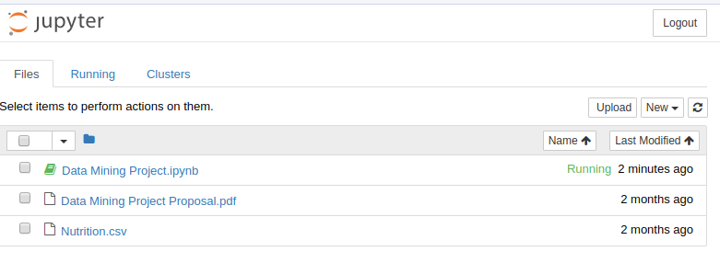

Now open the file and run as instructed in the notebook.